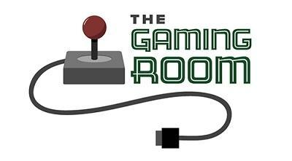

Draw It or Lose It

CS 230 Project Software Design Template
Version 1.1

Table of Contents

CS 230 Project Software Design Template 1
Table of Contents 2
Document Revision History 2
Executive Summary 3
Requirements 3
Design Constraints 3
System Architecture View 3
Domain Model 3
Evaluation 4
Recommendations 7

Document Revision History

Version | Date | Author | Comments
1.0 | 5/29/26 | Joe Teegarden | First draft of software design for Draw It or Lose It
1.1 | 6/13/26 | Joe Teegarden | Addressing Licensing Costs

Executive Summary

The Gaming Room wants to expand their Android game, Draw It or Lose It, into a web-based application that can run on multiple platforms. Right now the game only works on Android which cuts off a large portion of potential users. The plan is to build a web-based version of the app using java that runs on a server and can be accessed from any device through a browser. The game needs to be able to support multiple teams and players, keep all game and team names unique, and only allow one game to run in memory at a time.

Requirements

Business Requirements
- The game must be accessible on multiple platforms. Right now it is only Android.
- Game and team names need to be unique so users can check if a name is taken already
- Only one game can exist in memory at a time
Technical Requirements
- The app must be built for a web-based distributed environment
- The singleton pattern must be used in GameService to ensure only one instance exists
- The iterator pattern must be used to check for duplicate game, team, and/or player names before adding them
- The app must support multiple teams per game and multiple players per team

Design Constraints

The app has to run as a web-based distributed system meaning the game logic runs on a server rather than on each user’s device locally. Only one game can exist in memory at a time which requires the singleton pattern in the GameServices class. Game and team names also have to be unique, so the app checks for duplicates before adding anything new using the iterator pattern. Since this is moving from Android exclusive to a web platform, the code needs to work in a browser-accessible environment and can’t rely on anything specific to Android. The app also has to support multiple teams per game and multiple players per team at the same time.

System Architecture View

Please note: There is nothing required here for these projects, but this section serves as a reminder that describing the system and subsystem architecture present in the application, including physical components or tiers, may be required for other projects. A logical topology of the communication and storage aspects is also necessary to understand the overall architecture and should be provided.

Domain Model

The UML diagram shows seven classes in the com.gamingroom package. Entity is the base class and holds the common attributes id and name that every game object needs. Game, Team, and Player all inherit from Entity which is an example of inheritance. This keeps the code clean since those three classes don't have to repeat the id and name fields. GameService manages the list of active games and uses the singleton pattern so only one instance of it can exist at one time. Game holds a list of Teams and Team holds a list of Players which shows a one-to-many relationship at each level. ProgramDriver uses SingletonTester to confirm the singleton is working. Private constructors and public getters throughout the classes demonstrate encapsulation which keeps the data protected but still accessible.

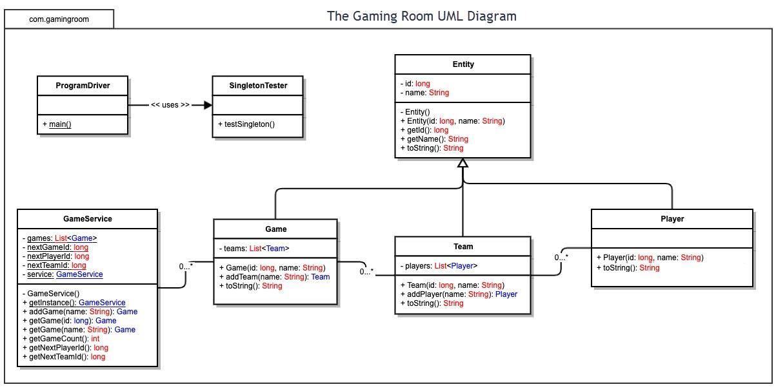

Evaluation

Using your experience to evaluate the characteristics, advantages, and weaknesses of each operating platform (Linux, Mac, and Windows) as well as mobile devices, consider the requirements outlined below and articulate your findings for each. As you complete the table, keep in mind your client’s requirements and look at the situation holistically, as it all has to work together.

In each cell, remove the bracketed prompt and write your own paragraph response covering the indicated information.

Development Requirements | Mac | Linux | Windows | Mobile Devices
Server Side | Mac is a good option for hosting a web-based application because it runs on Unix which makes it stable and reliable to act as a server. It can handle servers like Apache and nginx well and also works well with Java. The main problem is the cost since Mac hardware is typically more expensive. MacOS Server software is available but rarely used in production. They usually rely on third-party tools which have their own licensing costs on top of their already expensive hardware. | Linux is the most common choice for web servers since it is open source, free to use, and very stable for long term use. It supports all major web server software and Java environments well. The main weakness is that it is less user friendly and requires more technical knowledge. Licensing cost is zero since most Linux server distributions like Ubuntu Server are free to use which makes it the most cost-effective option for hosting. | Windows can host web-based applications and has good support for tools like IIS. It's familiar to most developers and much more user friendly than Linux. The downside is cost since Windows servers require licensing which can be expensive and it also comes with additional, usually strenuous, resources. Windows Server licensing typically runs several hundreds to thousands per license depending on the edition you need as well as Client Access Licenses. | Mobile devices aren't practical for hosting a server. They do not have the processing power, storage, or uptime to run a web server properly. They are better for accessing the application rather than hosting it.
Client Side | Supporting Mac clients is pretty easy since most modern browsers work the same across platforms. Since Draw It or Lose It is web-based, Mac users can access it through Safari, Chrome, Firefox, Opera, etc. without needing any extensions or addons. The main thing to ensure is that the UI looks the same across different browsers. | Linux clients can access the web app through any of the browsers previously mentioned. If someone is using Linux already, they more than likely have the technical knowledge, so compatibility wouldn’t be an issue. There wouldn’t be any additional cost for development to support Linux since the web app would work regardless of OS. | Windows is the most common client platform so it’s easily the priority. All major browsers are available on Windows and the application should work without any platform-specific issues. Testing on Windows is important since it covers a large portion of potential users and since the app is browser based it should translate to any other OS. | Mobile clients are important to support since many users will try to access the game on their phone or tablet. People who share the game with a friend are more likely to send it via text. The main considerations here are making sure the interface is responsive and format properly according to the screen size of the user. This may require additional game design work, but it wouldn't require any separate hosting or version.
Development Tools | Mac supports Java through tools like VS Code and Eclipse. It also works with most version control systems and build tools like Maven and Gradel. Mac is a popular development environment for Java-based projects. | Linux supports the same Java development tools as Mac. Many developers prefer Linux for development because of its performance and the ability to closely mirror a production server environment. All the tools are available and most are free. Linux also has less bloat from unnecessary background applications and tools that Windows provides. | Windows supports Java development through the same IDEs. Eclipse and VS Code both work well on Windows. One consideration is that some server-side tools behave slightly differently on Windows compared to Linux, so testing in Linux would be best. | Mobile devices are not used for development directly. Even if a native mobile app were needed, it would be developed in an Android or an iOS studio. Since this project is web-based, we do not need a mobile-specific development tool.

Recommendations

Analyze the characteristics of and techniques specific to various systems architectures and make a recommendation to The Gaming Room. Specifically, address the following:

- Operating Platform: Linux is the best option for The Gaming Room since it is free, stable, and widely used for hosting web-based applications. Since Draw It or Lose It needs to be accessible across multiple platforms, running it on a Linux server means any device that can access a browser will be able to reach it without needing any platform-specific software, extensions, or addons.

- Operating Systems Architectures: Linux uses a monolithic kernel architecture which handles the core system function like memory, file systems, and networking all in one place. It supports multi-user environments and can handle multiple simultaneous connections well which is important for a game where multiple teams and players are active at the same time. Most Linux server distributions like Ubuntu servers are lightweight and can be configured specifically for running Java web apps.

- Storage Management: A database like MySQL or PostgreSQL would work well for this application. Game, team, and player data need to be stored and retrieved quickly and a relational database handles that kind of structured data efficiently. Linux has a strong support for both MySQL and PostgreSQL and both also integrate well with Java apps.

- Memory Management: Linux manages memory efficiently by allocating resources to active processes and freeing them when they are no longer needed. For Draw It or Lose It, the singleton pattern in GameService helps keep memory usage predictable since only one instance of the game service exists at a time. The Java Virtual Machine also handles garbage collection automatically which reduces the risk of memory leaks.

- Distributed Systems and Networks: Since the game needs to work across multiple platforms, the application will run on a central server and communicate with clients through a standard web protocol like HTTP. Each device connects to the server through a network and the server handles all game logic. The main risks to consider are network outages and latency especially during active gameplay. Using a reliable hosting provider and building in error handling for dropped connections would help reduce the impact of those issues.

- Security: User data needs to be protected both on the server and during transmission. Using HTTPS encrypts data between the client and server so it cannot be intercepted. On the server side, Linux has strong built-in features that can access controls that limit who can interact with the system. Passwords should be hashed before being stored and user sessions should be timed out after a period of inactivity to reduce the risk of unauthorized access.

